Using dynamic geometry software to encourage 3D visualisation and modelling.

Adrian Oldknow
e-mail: a_oldknow@compuserve.com
University of Chichester
Chichester, West Sussex, UK

Linda Tetlow
e-mail: Lindastetlow@aol.com
University of Chichester,
Chichester, West Sussex, UK

Abstract
The Royal Society’s working group report on the teaching and learning of geometry 11-19 [6] recommended both greater attention to work in 3D and more effective use of ICT. The development of the award-winning Cabri 3D software now makes both of these goals achievable. The paper provides examples of the use of Cabri 3D in:
- topics within 3D geometry for students aged 11-16, such as symmetry, transformations, nets, 2D representations, areas and volumes;
- topics within 3D geometry for students aged 16+, such as equations of lines and planes, sections of cones and cylinders, use of vectors;
- activities which link subjects such as maths, technology, geography, art;
- opportunities for introducing new approaches such as to perspective and projective geometry.
The paper also draws on experiences gained in working with pilot schools on the introduction of the software to teachers whose own background in 3D (and other) geometry is not very strong.

1. Introduction
All pupils in English primary and secondary schools study mathematics up to the age of 16. The mathematics curriculum in English secondary schools for pupils aged 11-16 includes work in number, algebra, geometry and statistics. In some countries the rationale for including geometry in the secondary school mathematics curriculum is to give students experience of working within a formal system and to develop an understanding of the nature of proof [4]. Such an aim was largely abandoned within the English system following the school and examination reforms of the 1970s. The current curriculum, described as `Space, shape and measures’, contains an eclectic mix of descriptive, plane, vector, coordinate and 3D techniques [6]. In post-16 mathematics the major content is coordinate geometry in the plane.
Most primary school pupils gain a good experience of work in three dimensions through the physical manipulation of objects, using construction kits and toys, producing drawings, making models from drawings, describing the shape and feel of hidden objects by touching them etc. However on transition from the primary school to the secondary mathematics classrooms, the consolidation and development of such work virtually evaporates. One major reason for this is the difficulty of arranging practical work in the normal classroom. Another is in the knowledge and confidence of mathematics teacher about 3D geometry.
Most primary and secondary schools in England are now very well equipped with Information and Communication Technology (ICT), and the UK is acknowledged as a world leader in the use of ICT to support whole class teaching – particularly through the use of Interactive Whiteboards (IWB). Recent government statistics show that in 2005 there was an average of about 1 computer to 6 pupils in primary schools and to 3.7 pupils in secondary schools. Also that, on average, primary schools had 5 IWBs and secondary schools 17 [1] – figures which have doubled for each of the previous 4 years. A particular challenge in mathematics education in English secondary schools currently is to develop effective pedagogy using such resources to enhance teaching and learning mathematics – see for example [5].
Dynamic geometry packages, such as Cabri II Plus, the Geometer’s Sketchpad and Geogebra, are very well suited for use in 2D geometry both in whole-class work (particularly with an IWB) and for supporting investigations by individuals or small groups. Each also provides a (possibly limited) means of production of interactive `applets’ using Java for web-pages containing geometric manipulatives. Students and teachers can interact with such applets without having the original software installed. This document contains hyperlinks both to the original Cabri 3D files illustrated in the text, and to html files which can be manipulated once the Cabri 3D plug-ins have been installed – see below.
The paper is based on the presentation made at the 8th International Conference on Teaching Mathematics with Technology in July 2007. It reports on preliminary development work undertaken by the authors with teachers and students in a small-scale pilot project. This is now being extended into a larger project in a group of Hampshire schools and the intention is to report on the effects on pupils (and teachers) at ICTMT-9 in 2009.

2. Cabri 3D software
Against the background described above, the Cabri 3D software from CabriLog provides a revolutionary means of bringing a range of interactive, ICT-supported explorations of 3D space into both the mathematics classroom and into pupils’ homes. The software has a familiar `feel’ to its 2D predecessors and so it is quite easy to pick up and get started with [7]. The main representation on screen is a true perspective drawing of the objects created within the software, but many other representations are also available – such as isometric and cylindrical projections. If you hold the right mouse button down while dragging you can `spin’ the image in space so that you can observe it from different viewpoints, and so build up your own internalised 3D visualisation of the model. Instead of linking with Java, the software is built in the Cabri Mark-up Language (CML) which is an extension of the common Worldwide Web Consortium’s Extensive Mark-up Language (XML). This means that once files have been created they can be imported in other software, such as MS Office, as embedded objects. On screen these initially appear as still images. However if the necessary CML plug-ins have been installed then the images will `come to life’ and can be used interactively. The plug-ins are automatically installed when either the full or the trial version of the software is installed, and they can also be downloaded free from the CabriLog website. http://www.cabri.com/download-cabri-3d.html#plugin. This latter feature opens up a new vista for the production of mathematical manipulatives.

3. Examples from 11-16 geometry
A simple starting point is the set of regular, or Platonic, solids – drawing analogies from what is known about regular polygons in 2D. Most mathematics teachers know about the tessellation properties of regular polygons, but few have ever considered their generalisation to 3D, other than bricking up space with cuboids! So, here is an example of using Cabri 3D to build up a regular tetrahedron from an equilateral triangle in the ground plane with centre O and vertex A. The base triangle is then given a half-turn about each of its edges to produce the net of the tetrahedron. Tetrahedron.cg3 and Tetrahedron.html .
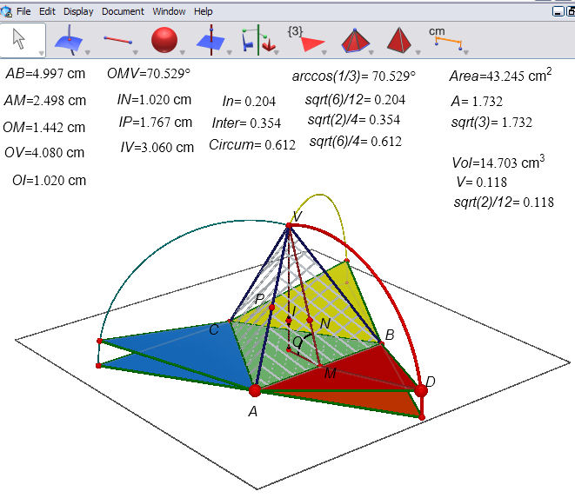
Figure 1: the net of a tetrahedron

Circles around AB and AC through vertices of the base triangle meet in the vertex point V. The point D is taken on an arc of one of the circles. The red triangle is rotated about its edge AB by the angle defined by its third vertex and the point D. Thus D has now become a `slider’ which can be moved to make one of the sides of the tetrahedron appear to fold up towards V. By rotating this new triangle around the vertical axis OV twice, each time by the angle defined by B and A, we obtain the `dynamic net’ of the solid. The actual tetrahedron can be constructed as the pyramid with the base triangle ABC and vertex V – it is shown with a pale hatching. In this particular example we have taken measurements from the mathematical model to use as checks against pencil-and-paper work to calculate dimensions of objects in 3D. The side-length d of the tetrahedron AB can be changed by dragging the point A. The dihedral angle is ∠OMV where M is the mid-point of AB. Can you find expressions for the lengths OM, OV, VM in terms of d, and hence find ∠OMV? In plane geometry triangles have in-centres and circum-centres – is the same thing true for tetrahedra in 3D geometry? The perpendicular bisector of AV meets OV in I, which must be the circum-centre of ABCV – why? The radius of the circum-sphere is IV – can you find an expression for it in terms of d? The plane through I perpendicular to MV meets MV in N, so the sphere centre I through N touches each of the four faces of the tetrahedron. Can you find an expression for the in-radius IN?
The plane through I perpendicular to the edge AV meets AV in P, so the sphere centre I through P touches each of the six edges of ABCV. Can you find an expression for the inter-radius IP? How about expressions for the surface area and volume of tetrahedron? See [3], [8] and [9] for more material on Platonic (and other) solids. Starting from a regular tetrahedron it is easy to build up a more complex solid around a vertex such as A by continually `gluing’ identical tetrahedra on the faces. However hard you try, though, you cannot completely `brick’ A in by such tetrahedra. So, surprisingly, regular tetrahedra do not fill space. If they did the point A would be the centre of a solid whose faces were identical equilateral triangles – and there are only three such solids: the tetrahedron, octahedron and icosahedron. Clearly the first two can be rejected. There would be exactly 20 tetrahedra around A if the circum-radius of the icosahedron was the same as its edge-length – is it?
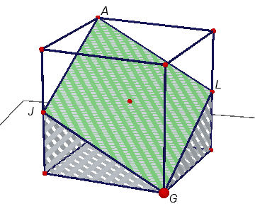
Figure 2: a cross-section of a cube

Another brief example will show some of the more powerful features of the software. Here a cube has been created, and a polygon AJGL formed using two opposite vertices and two midpoints of edges. What shape is AJGL? How could you test to see if it is a square? The hatched shape below the polygon is the result of cutting the cube by the plane containing the polygon. If you reflect it in the polygon will you recapture a complete cube? If not, what transformation would do so? Cube.cg3 and Cube.html .

4. Examples from 16-19 geometry
Here we will build a `cone-slicing’ machine. The point A can slide vertically on the z-axis to define the depth of the shown part of the cone. The point B can slide horizontally on the y-axis to define the radius of the cone. The point C can slide in the ground plane and is the centre of a sphere of fixed radius. The point D can slide around its equator and the point E along the longitude through it. The point F can slide on the ray CE. The plane is the perpendicular to CF through F. The intersection curve of the plane and the cone is shown. Can you adjust the plane so that the cut becomes a circle, a hyperbola, a parabola, a point, a pair of lines..? This is a good example of a model suitable for turning into an interactive applet – there are 6 control points for you to vary. Cone slicer.cg3 and Cone slicer.html .

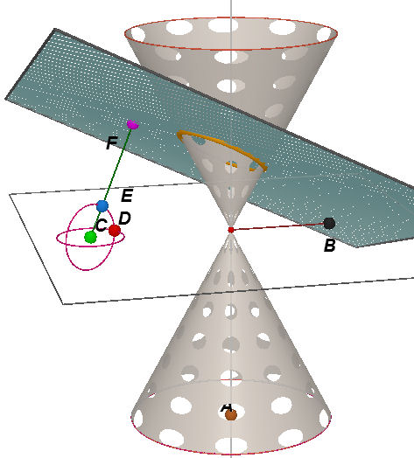
Figure 3: slicing through a cone

At the time of writing the analytic capabilities of Cabri 3D extend to points, lines, vectors, planes and spheres – not conics or surfaces.

5. Cross-curricular examples
An important matter of concern in English education currently is the need to attract more students to pursue higher and further education in aspects of Science, Technology, Engineering and Mathematics (STEM) which are seen as being fundamental to the country’s future economic needs. Science and mathematics, along with English, are the `core’ subjects in our National Curriculum. The subject known as `Design and Technology’ is a `foundation subject’ which brings together a range of modules concerned with designing, testing and making using, for example, electronics, mechanisms, resistive media (wood, metal, plastic..), textiles, food stuffs etc. Many schools now have workshops equipped with CADCAM systems as well as state of the art peripherals such as laser cutters and 3D printing. In this context, work in 3D is an excellent source of opportunities for cross-curricular collaboration between teachers of STEM subjects. In one group of schools pupils decided to develop a project around designing portable, temporary accommodation for use in disaster relief. After searching the Internet one group of pupils came up with this design based on a `yurt’ – a type of tent used by nomads in Mongolia. Yurt.cg3 and Yurt.html .

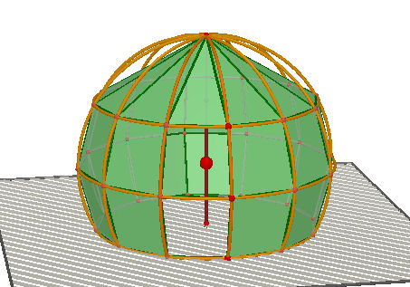
Figure 4: a yurt designed with Cabri 3D

There are many examples of simple mechanisms which can be modelled in Cabri 3D, see e.g. [2]. The one chosen by this pair of students is the animation of a piston oscillating at the end of a slider-crank linkage. The nearer model has points which control the dimensions of the mechanism. The further model has the same dimensions but is designed to move as the point H traverses the circle. You can set the model in motion and then explore the effect of changing any of the control dimensions. Piston.cg3 and Piston.html .

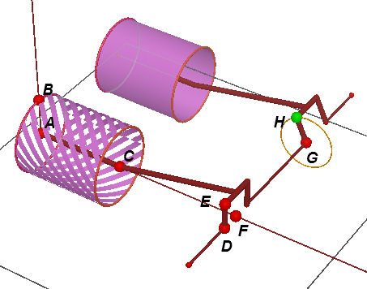
Figure 5: pistons modelled in Cabri 3D
Two obvious applications in science are in the geometry of molecular and crystal structures, and in the orbital motion of planets around the sun, or electrons around a nucleus. The latter example provides another nice application of animation.

6. Perspective and projective geometry
Students live in a world which is full of computer generated images – such as the special effects in movies and games. As mathematics teachers we should be aware that these are just visible results of some very clever mathematics – in this case computational geometry for computer graphics. In order for objects created with `virtual reality’ software accurately to resemble the real world, the 2D representations of computer-generated 3D objects must obey the rules of perspective drawing. We have seen an enormous rise in the ability of students to produce their own digital images e.g. through cameras in mobile telephones. Through a study of the parallel lines in such images students can `discover’ the rules of perspective, and with the aid of the Internet perhaps seek to learn something themselves about Renaissance painting and architecture – including the camera obscura. With Cabri 3D they can make simple models of the eye such as the one shown here, where the retina is taken as a region of a sphere and the image is formed where rays of light from the object, through the lens L, strike the sphere again. Eye.cg3 and Eye.html .

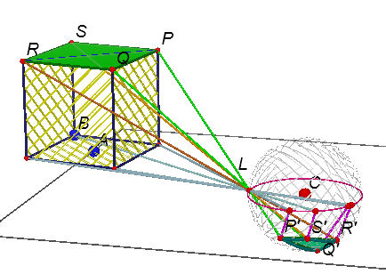
Figure 6: modelling the retina of an eye

The same model can be used for a simple camera where the image is formed on the face of a cuboid opposite the lens. camera.cg3 and camera.html .

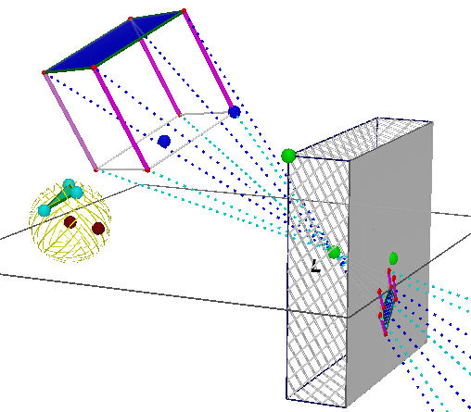
Figure 7: modelling a camera

In order to model a reflecting telescope we take rays from the object parallel to the telescope’s axis and reflect them in parabolas to pass through the focus, and to be gathered on a small eyepiece screen. Telescope.cg3 and Telescope.html .

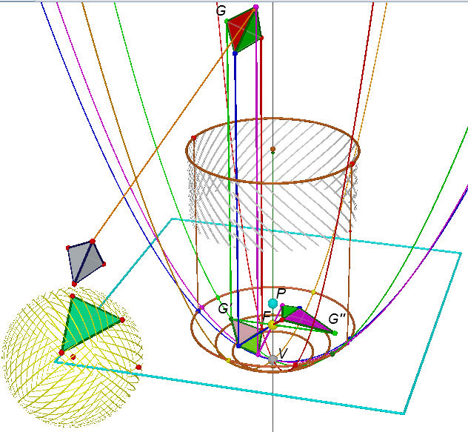
Figure 8: modelling a reflecting telescope

It would be nice to think that such a powerful tool harnessed with the natural curiosity of youth might inspire some students to find out more about the geometry which has virtually disappeared from view nowadays – projective geometry – and to find out more about the work of people like Pappus and Desargues!

7. Conclusions
Teaching 3D geometry beyond primary school level has presented real problems to many teachers, especially when pupils, and teachers, have very limited spatial awareness themselves. Cabri 3D is a revolutionary software tool which has the capacity to bring this important aspect of mathematics to life in a visually motivating way. While its basic tools are relatively easy to master, the art is in choosing tools and strategies to solve problems – and this will be a new experience to most teachers as well as their pupils. The software architecture provides a major new opportunity for curriculum developers to produce interactive resources (manipulatives) which will improve users’ abilities to visualise in 3D. The software also allows users to explore models built by others and to develop their own problem solving techniques in adapting and creating models themselves. These support pupils’ creativity and curiosity – so the challenge is for teachers to develop an appropriate pedagogy to put this to best effect.

8. References
- Becta, The Becta Review 2006, The British Educational Communications and Technology Agency, Coventry, 2006.
- Bolt, B., Mathematics meets Technology. CUP, Cambridge, 1991
- Cundy, H.M. and Rollett, A.P., Mathematical Models, Tarquin, Norfolk, 1981.
- Hoyles, C., Foxman, D. and Küchemann, D., A Comparative Study of Geometry Curricula, Qualifications and Curriculum Authority, London, 2002.
- Oldknow, A. (ed.), ICT and Mathematics: a guide to learning and teaching mathematics 11-19, The Mathematical Association, Leicester, 2005.
- Royal Society, Teaching and Learning Geometry 11-19, Royal Society, London, 2001.
- TEEM, Cabri 3D, Teachers Evaluating Educational Multimedia, St.Ives, 2006:
http://www.teem.org.uk/1948/.
- Wells, D., The Penguin Dictionary of Curious and Interesting Geometry, Penguin, London, 1991.
- Zeeman, C, Three-Dimensional Theorems for Schools, The Mathematical Association, Leicester, 2005.

